***Competitive Programming: Intermediate to Advance***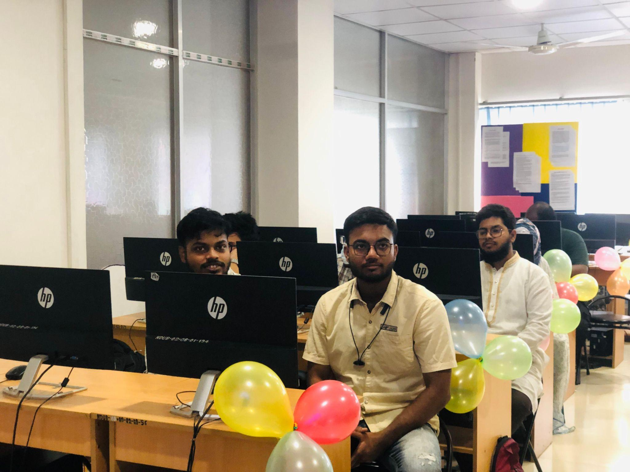

The Department of Computer Science and Engineering (CSE) has launched a three-month-long course titled *“Competitive Programming: Intermediate to Advance,”* aimed at enhancing students' problem-solving skills and preparing them for national and international programming contests. The course began on April 12, 2025, and will continue for the next three months with weekly sessions held every Saturday from 9:30 AM to 12:30 PM. The initiative is designed to guide participants through advanced concepts in algorithms, data structures, and competitive problem-solving strategies.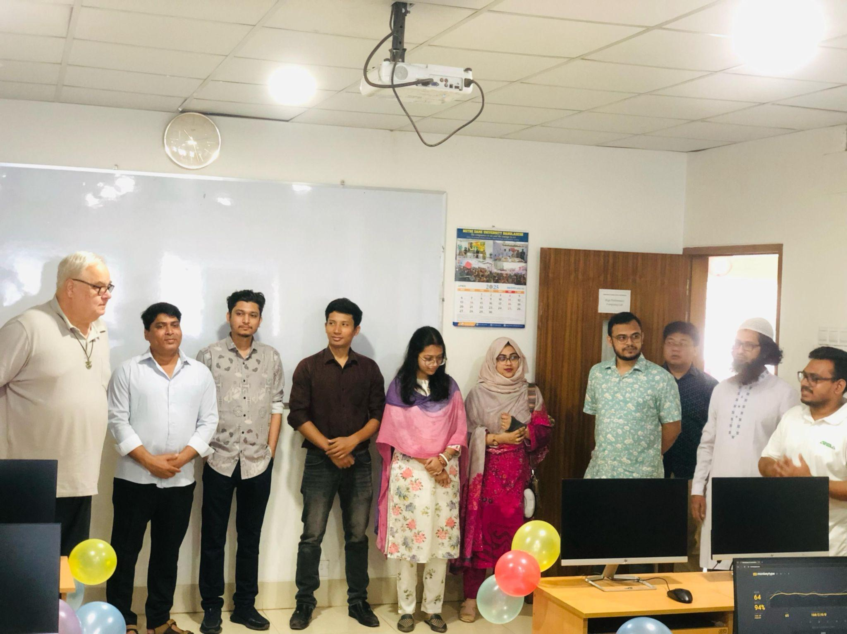

The inaugural session of the course was graced by several esteemed university officials Fr. Charles B. Gordon, CSC, the Pro Vice-Chancellor, Fr. Ashim Theotonius Gonsalves, CSC, the Deputy Registrar, and Fr. Adam S. Perera, CSC, the Treasurer. Faculty members from the Department of CSE were also present at the event, notably the Head of the Department, A. H. M. Saiful Islam, alongside Nafisa Tabassum, Lecturer, Mondira Chakraborty, Lecturer, Khorshed Alam, Lecturer, and others who were captured in the official photograph taken during the event.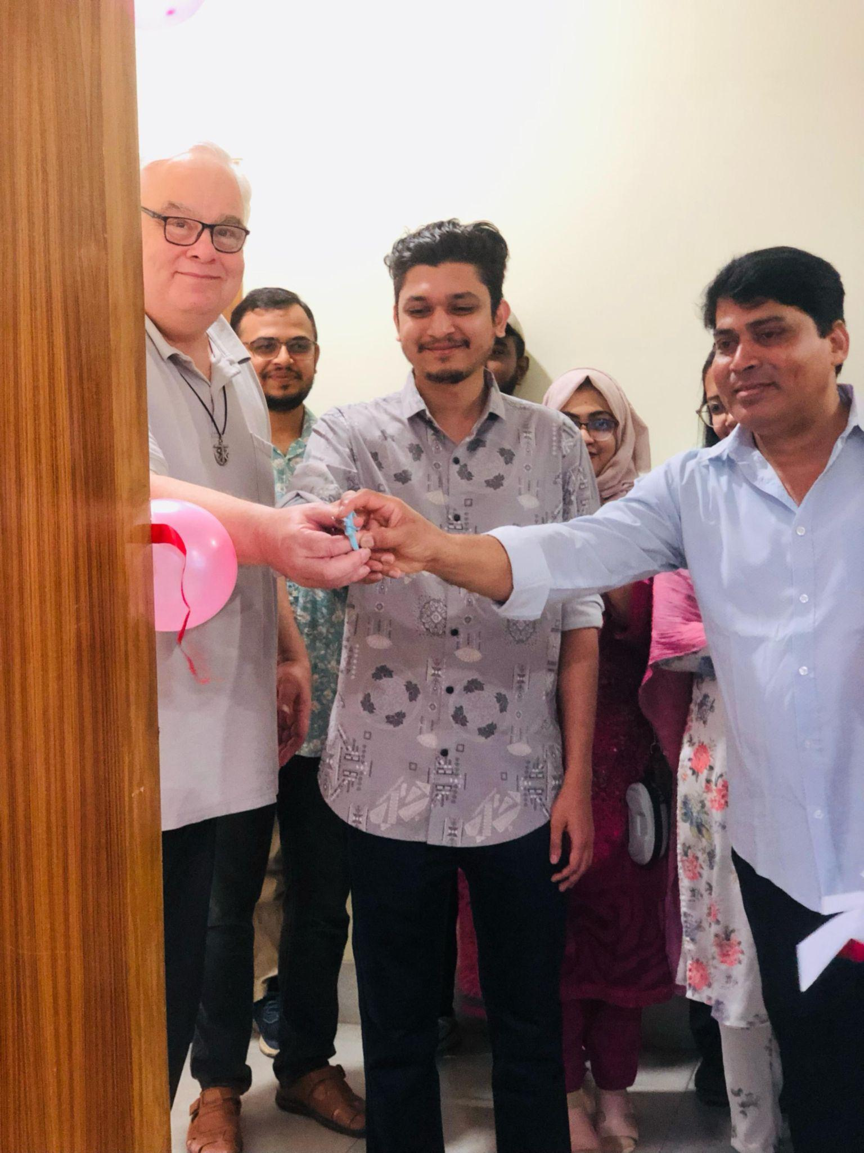

The course is being conducted by **Md. Tanvir Rahman Tareq**, a skilled competitive programmer and Software Engineer at Therap BD Ltd. He holds a B.Sc. in CSE from SUST with a CGPA of 3.60. He has earned titles like Candidate Master on Codeforces (Top 0.03%), 5-star on Codechef (Top 1%), and holds a high Leetcode rating of 2283. Tanvir has also performed remarkably in international contests, earning Meta Hacker Cup T-shirts four times and securing 225th place globally in Google Kickstart. 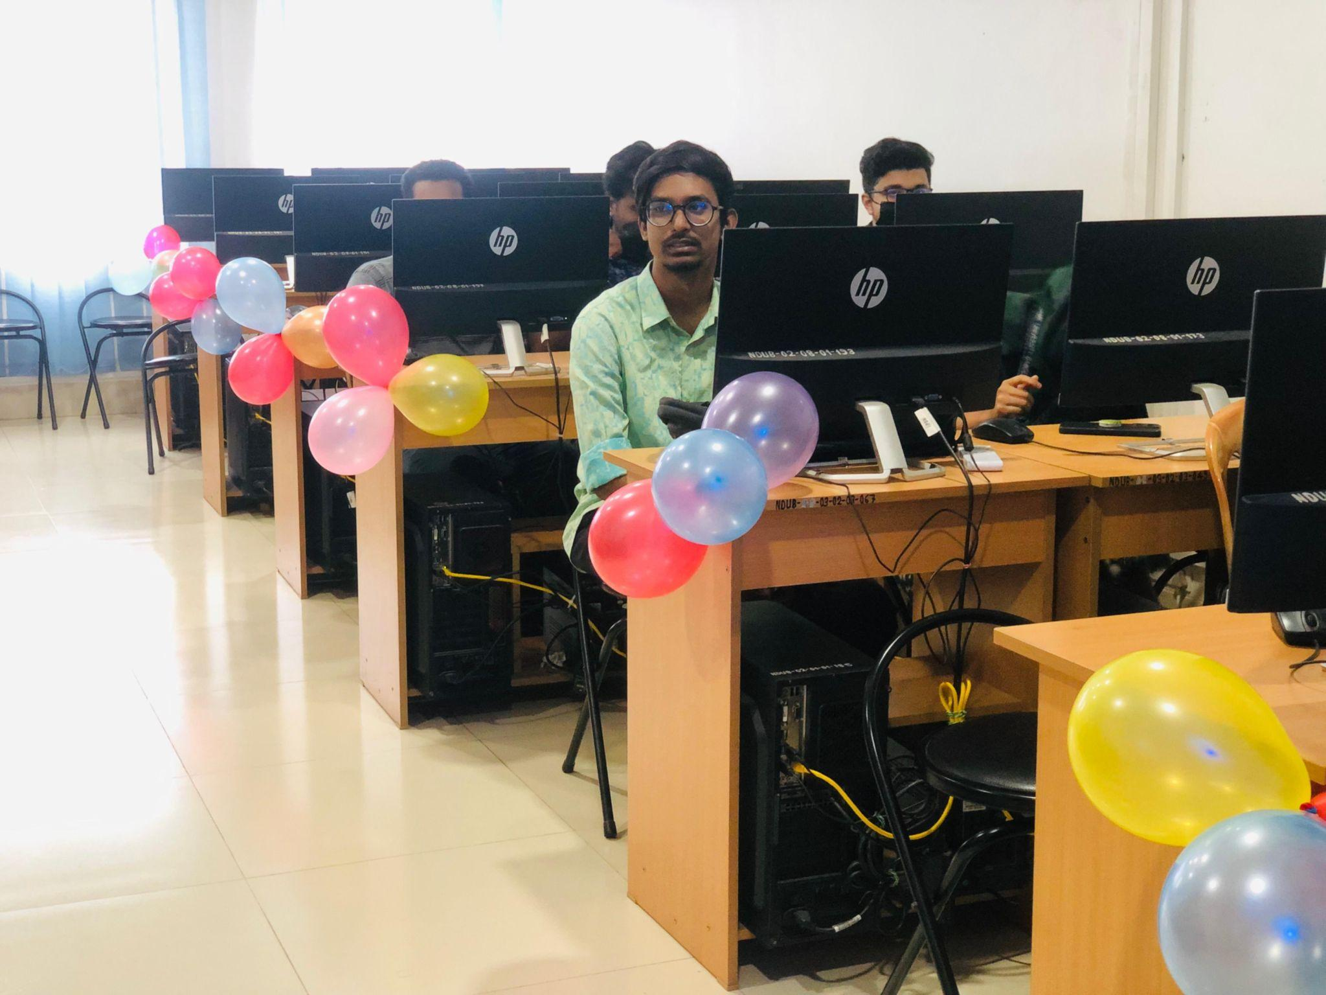

In team contests, he placed top 10 in ICPC Asia Dhaka 2021 and Cefalo CodeFiesta 2022, and 3rd in the Intra SUST Contest 2020. As a mentor and judge, he has contributed to various programming contests and camps, including the SUST CSE Carnival 2024 and SUST Competitive Programming Camp, where he trained over 100 students.

This course reflects the Department’s commitment to fostering a strong culture of programming excellence and innovation. Through interactive problem-solving, practical sessions, and expert mentoring, students are expected to significantly elevate their competitive programming capabilities.